
QUALITY ALERT

Customer: AVANTI Date: Mar 17, 2025
Die: 15901 Colour: ALL
Type of Complaint: REJECTED

Q.A # Q.I.R # CUSTOMER NCR #

Description: Customer REJECTED because the middle tower off square and bottom wall not flat make it can’t fit in the punch and cannot weld.
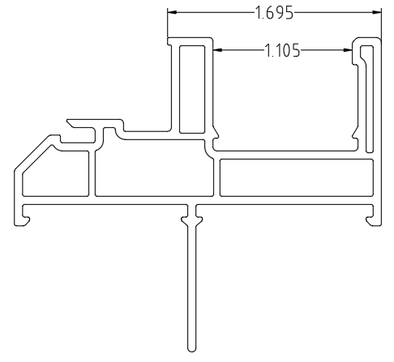
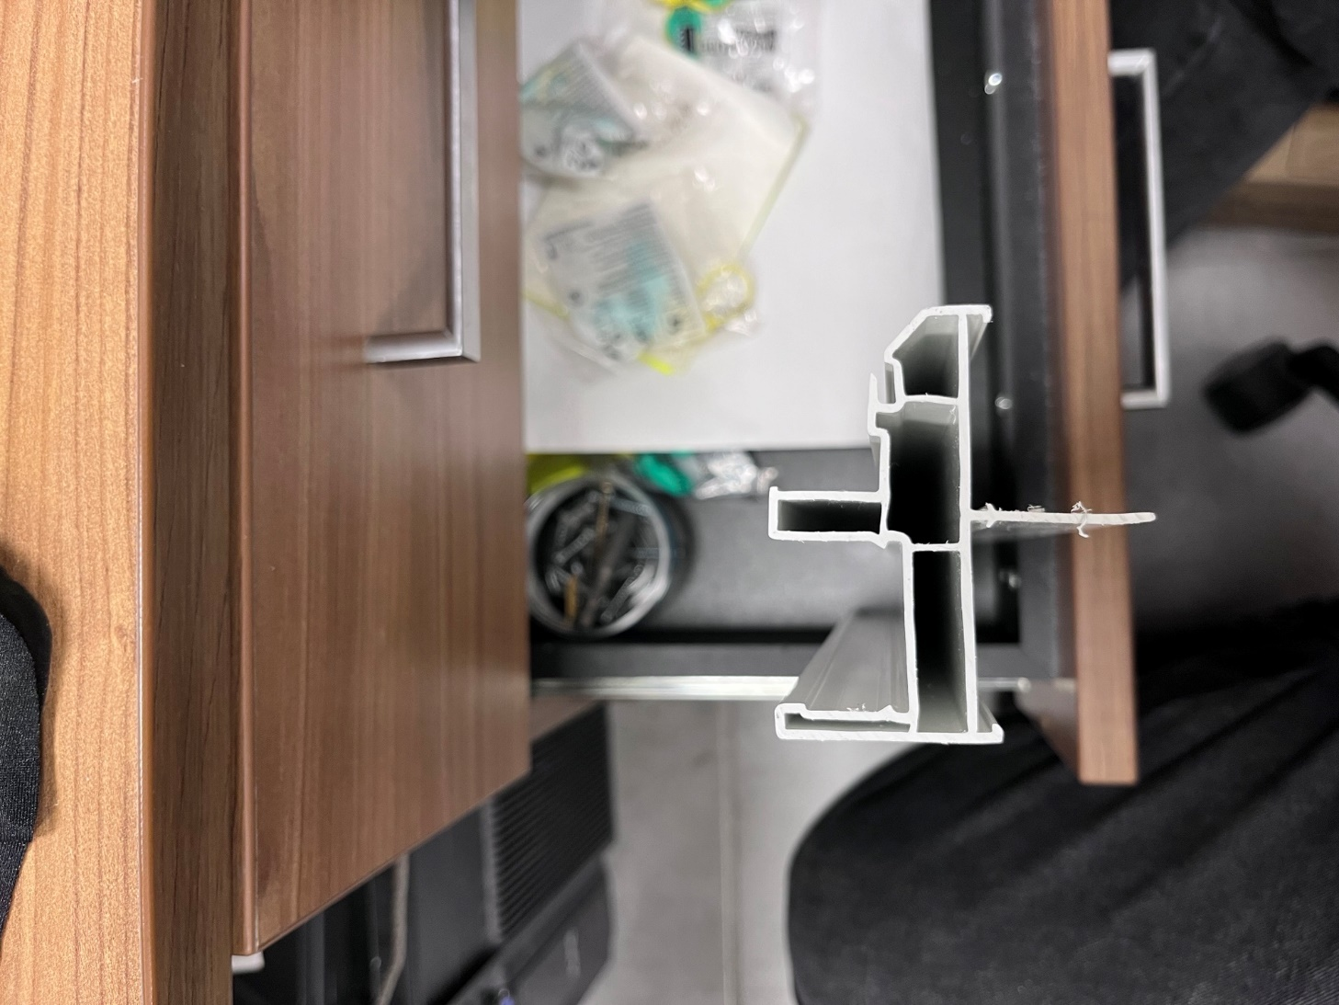
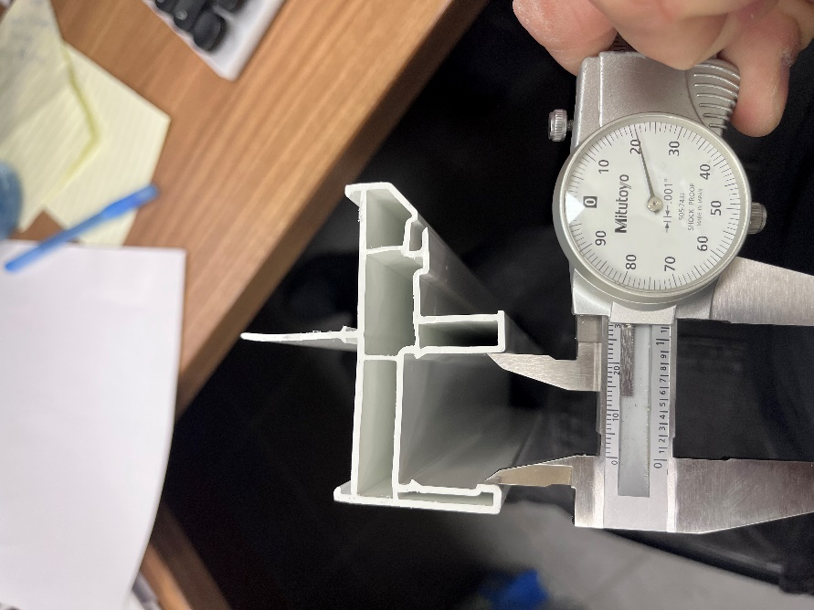

BOTTOM WALL MUST FLAT

PLEASE MAKE SURE THE PIECE SQUARE AND WITHIN DIMENSION TOLERANCE.

BY SIGNING BELOW, YOU ACKNOWLEDGE THE PROBLEM ABOVE AND AGREE TO MONITOR THIS ISSUE IN FUTURE PRODUCTION RUNS.
DAY SHIFT |  | AFTERNOON SHIFT |  | NIGHT SHIFT
NAME | SIGNATURE | NAME | SIGNATURE | NAME | SIGNATURE

